16+ Recreational Session Grant – Wall Net Slider

Applications for the grant will close on Friday 10th February 2017. Once completed the form should be emailed to s.harding@volleyballengland.org

Club Details
Club Name
Contact Name |  | Role of Applicant
Contact Number |  | Email Address
Address of Club
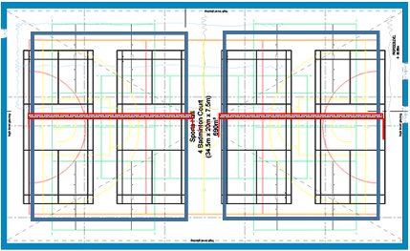

Criteria (Must be fulfilled to be accepted)
 | Criteria for Grants | Tick YES if correct
1 | Your club is affiliated to Volleyball England for the 2016-17 season
2 | Based within a Leisure Centre? (Applications from clubs based in schools, colleges and universities will be considered)
3 | The venue you intend to install the Wall Net Slider at does not have underfloor heating
4 | Permission in place to drill floor and wall for installation (copy of an email or letter of approval from venue owner/operator is attached to this application)
5 | Your club to provide £200 inc. VAT partner funding to support the £820.00 inc. VAT project. (this must be detailed in the venue owner/operator letter attached to this application) - a Purchase Order will be requested upon acceptance of your application.
6 | Photo’s attached of floor, both walls at each end of the sports hall or any potential obstacles for installation (see attached photo guidance for required quality and number of photos)

Name of Venue for Installation
Contact at Venue |  |  | Role of Contact at Venue
Contact Number at Venue |  |  | Email Address of Contact at Venue
Address of Venue
Hall Size in Metres | ……..m Length x …….. m Width (IMPORTANT: Nets supplied are 33m long, therefore may not fit all sports halls. Custom nets are available at an additional cost to you)
Type of Floor? | Suspended wood | Granwood or similar ceramic |  | Synthetic surface e.g. Taraflex
 | Other, Please specify…..
Can you install the equipment by 31st March 2017? |  | Yes |  |  |  | No

The diagram (above) illustrates the net spanning the length of sports hall.
Click HERE to view a video of how the net is installed in a sports hall

Click HERE to view the technical specification of the equipment

Delivery
Guidance
Please fill in the table opposite to tell us the current number of 16+ participants at your club and the target number of new regular participants you expect to gain due to the installation of a wall net slider.
 | Regular Participants | Projected Regular New Participants after 1 year
Aged 16+
Explain the need for a Wall Net Slider? (In approx. 300 words)

Include why this equipment is required e.g:
- Current equipment not fit for purpose
- Wish to start a new session?
- Wish to increase the number of participants training/playing at once
- Create a new local league team

Detail:
- How many new members you looking engage?
- What day and time will training take place?
- How many participants are you looking to accommodate at once?
- Who have you consulted with regarding this new equipment e.g. venue provider?
- What equipment are you currently using?

Guidance
Please tell us how the installation of the wall net slider will impact upon your volleyball provision. Be specific.

Guidance
Please tell us who you have talked to at your club regarding the project and briefly what they have said to support this project. Additionally, anyone externally you have consulted regarding this project e.g. venue provider, your County Sports Partnership, local sports development unit

Guidance
Please provide details of how volleyball provision will be increased at your club, for those aged 16+ and playing recreational volleyball. You may want to include a timetable of current club activity and details of new activity as a result of the installation

