2014/15 has proved to be a very successful year for developing volleyball at grass roots level across Dorset. In my role as Volleyball Relationship Manager in the Dorset and Hants Volleyball Investment Zone, Active Dorset County Sports Partnership have been a key partner in achieving this success. They have not only provided considerable funding to start up various volleyball programmes but their knowledge and expertise of sport and physical activity at a local level has opened doors to even more volleyball opportunities.
This year Active Dorset and Volleyball England have provided funding to establish 3 Volleyball Satellite Clubs delivered by Wessex Volleyball Club. These Satellite Clubs have been set up in areas where there has historically been a strong emphasis on volleyball including Parkstone Grammar School, Leaf Academy and Lytchett Minster School. The purpose of these clubs has been to provide young people aged 14-25 with access to community volleyball clubs delivered by club professionals from Wessex Volleyball Club.
In terms of Further Education I have been successful, with Active Dorset’s support, to introduce volleyball to the main two Colleges in Dorset, Bournemouth and Poole College and Weymouth College. The Colleges have applied for Sportivate funding through Active Dorset or self-funded themselves to recruit local qualified club volleyball coaches which has only further enhanced the quality of these sessions and offered students an exit route.
I have been able to support 6 GO Spike sessions this year in Dorset, with Active Dorset and Volleyball England funding. These Go Spike sessions offer adult recreational volleyball to all levels of ability for people aged 18-25 and locations include Weymouth Beach, Bournemouth YMCA, David English Sports Centre, Leaf Academy and Beaminster School.
This year we have also been successful in staging the first UKCC Level 1 Volleyball Coaching Course to be hosted in the County at Leaf Academy. Working closely with Active Dorset we were able to attract 17 candidates and offer applicants delivering specific projects around my work programme a bursary to help with the costs of the course.
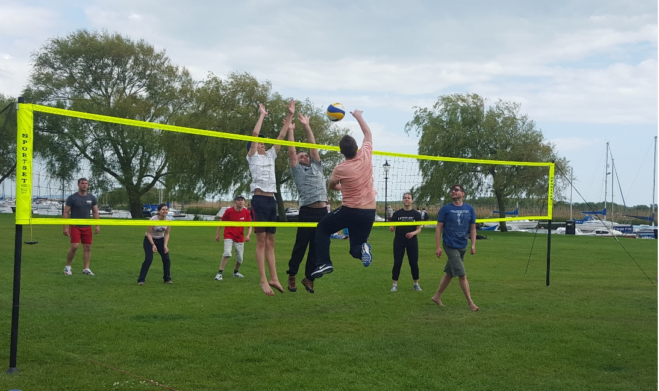
The photo above was taken from Christchurch Quay where Bournemouth Volleyball Club delivered a GO Spike event as part of the GO Spike Big Weekend in May. It was one of 4 GO Spike events to be staged across Dorset over the Bank Holiday weekend.

