Safeguarding children and adults at risk: are you compliant?

Working with children and vulnerable adults means that Sporting Organisations are required to take extra precautions regarding the individuals working with these members. The Safeguarding Vulnerable Groups Act 2006 provides the measures these organisations are required to follow to protect their members. However, these requirements are being changed by the introduction of the Protection of Freedoms Act 2012 (“the PFA”). Many of the changes introduced by the PFA came into force on 10 September 2012. These include new vetting requirements for individuals who will be working with children and vulnerable adults.

It is important that organisations understand and introduce measures to comply with the changes. An organisation is allowed to go beyond what is legally required but this needs to be reflected within the rules and regulations for the organisation and can only go as far as what is considered to be reasonable.

There are three significant changes which will affect the sport and recreational sector.

Definition of “Regulated Activity”

Old Definition New Definition
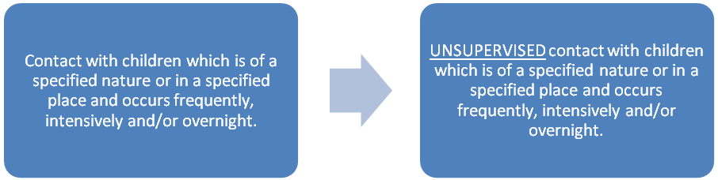

The ISA (Independent Safeguarding Authority), which will merge with the CRB (Criminal Records Bureau) to form the Disclosures and Barring Service (“DBS”) in December 2012, maintains a barred list of individuals not permitted to work with children in Regulated Activity. An organisation intending to engage an individual to work in Regulated Activity is obliged to check the barred list. Organisations are legally obliged to forward information about any individual who has been removed from Regulated Activity (or would have done had they not already left) because they harmed or posed a risk of harm to children or vulnerable groups.

The PFA limits those engaged in Regulated Activity to those who are “unsupervised”. Supervision is defined by the PFA as “such day to day supervision as is reasonable in all the circumstances for the purpose of protecting any children concerned”. Organisations are allowed to interpret the definition in a way that is best suited to their own particular circumstances. The Government has provided guidance to help organisations and to assist in ensuring the safety of children and adults at risk. This guidance indicates that the key issues organisations might take into account are the age/number of children; whether there are other adults around; the vulnerability of the children; nature of the contact; experience and checks previously carried out on the individual being supervised; and the number of people being supervised.

If an individual is supervised (and therefore not engaged in Regulated Activity), then the organisation can still request a criminal background check but they cannot have them checked against the barred list.

Single Disclosure

Old New
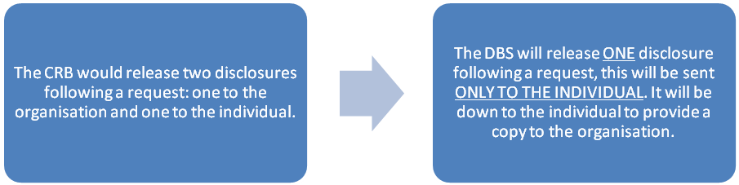
Under the PFA an organisation will be notified by the DBS when a disclosure is issued and will be informed whether it is clear of information or not. However, if it is not clear, no details contained in the disclosure will be provided to the organisation.

Organisations should consider putting in place new policies regarding disclosures. For example, organisations could adopt a policy whereby all disclosures are provided to them, whether clear or not, prior to the organisation offering a position. This allows the organisation to perform a risk assessment on individuals whilst allowing the individual to voluntarily withdraw from the process without providing any information on their disclosure.

By requesting all disclosures the organisation can protect itself from any potential error in the notification provided to them. Policies should also include provisions for what action will be taken if an individual refuses to provide the disclosure, time scales within which the disclosure must be provided and provision for the organisation to chase the individual for it.

When an individual is already in Regulated Activity and the organisation becomes aware that the disclosure is no longer current, they can ask the individual to request a new disclosure. Once the individual has received their disclosure but has not provided the organisation with a copy before 21 days have passed then the organisation can request a disclosure direct from the DBS. This allows the organisation to get information without relying solely on the individual.

Continuous Updating and Portability

Old New
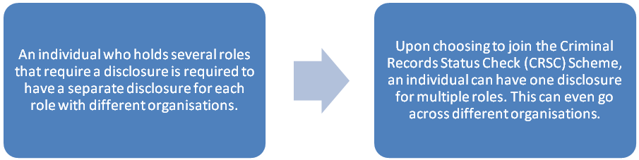
An individual can choose to join the CRSC scheme, which will allow them to hold one disclosure for multiple roles. Once an individual has joined the CRSC scheme, they will be issued with a disclosure and a unique number. The individual can then share this with multiple organisations who in turn will be able to check it is up-to-date by using the unique number to log-in to the scheme portal. If new information appears on the portal, an organisation will still not be able to see the details but can ask the individual to request a new disclosure and to share that with them.

An organisation should include provision within its policy of a suitable time period for when they should log-in and re-check the disclosure, when a new disclosure is needed and the requirement to provide that new disclosure to the organisation. This could then mirror the policy put in place regarding the single disclosure provisions (see above).

There are limitations to the CRSC scheme. It is wholly dependent on membership by the individual and is only applicable to the particular area it has been given for, for example a disclosure given for working with children can only be portable for a role in Regulated Activity working with children. It is important to note that an organisation is responsible for monitoring the portal and will not be told automatically if a disclosure changes.

Conclusion

It is important to understand the changes the PFA introduces and the implications it will have. Drafting new rules and/or policies that cover the changes is essential to protect children and adults at risk and to ensure that you, as an organisation are compliant.

If you require any further information or would like your rules reviewed in light of the changes please contact Laura Heeley or Nathan Talbott at Wright Hassall on 01926 886688. Check out our website www.wrighthassall.co.uk for their email addresses and other contacts within our Sport Law team.

