Secretary:
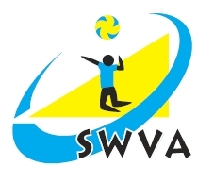
Ron Richards

3 Woodside Grove

Henbury
Bristol
BS10 7RF

tel: 0117 950 6965
mob: 0797 685 0618
Email: Rricha7122@aol.com

April 10th, 2015

Dear Executive Officer / Area Secretary

I would like to provide you with notice of the SW Volleyball Association Annual General Meeting. This will take place on Saturday June 2nd at Priory Community School, Queensway, Weston Super Mare, North Somerset, BS22 6BP at 10.30am.

I hope that you will be able to attend and help us to plan the future of volleyball in the SW.
Lunch will be provided at the end of the AGM and it would help me if you could let me know on the attached slip if you will be attending or not. (I would be grateful for replies by May 24th).

I will distribute the agenda and Annual Report as soon as possible after May 29th. Could I please therefore ask you to send OFFICERS / AREA REPORT TO ME BY May 23rd. - Email Rricha7122@aol.com.

Could you please let me know if you would be willing to stand or if you know of other suitable candidates willing to stand for office.

I have also attached a nomination form for the 2018 SWVA Annual Awards. Please nominate suitable people and please promote among your clubs / players. The form can also be accessed on the SWVA website: http://www.swva.org.uk/annual-awards-form

Yours sincerely

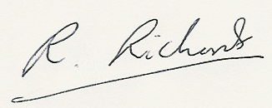

Ron Richards
Secretary SWVA.

SOUTH WEST VOLLEYBALL ASSOCIATION

2018 AGM – PRIORY COMMUNITY SCHOOL, WESTON SUPER MARE
SATURDAY June 2nd, 10.30am

Name (Block Capitals)............................................................ Club.....................................................................

Address..................................................................................................................................................................

Email .............................................................Tel No....................................................

Please circle / tick as necessary: I will be attending the AGM - please order me a lunch.

I am unable to attend the AGM - please present my apologies.

Please send me / do not send me a copy of the Annual Report by email

I would like to nominate the following for office at the AGM:

Position Present holder My nomination

Chairman Dave Reece .................

Vice Chairman Roy Pankhurst .................

Secretary Ron Richards . ................

Treasurer Vacant .................

Competitions Secretaries Rachel Swindell .................

Officials Sec Chris Semmens .................

Coaching Sec Jurek Jankowski .................

Jun Dev Officer Jurek Jankowski ................

Beach Volleyball Dev Officer Vacant .................

Sitting Volleyball Dev Officer Andrew Potter .................

Child Protection Officer Neil Bentley .................

Executive Officers:

Ros Sutherland ………… Anna Maria Lotowska ……….

Charlie Huitson ………… Cliff Ball ...............

Richard Parkes ………….

Signed ................................................................ Date ..................

Please return to Ron Richards (rricha7122@aol.com) tel 0797 685 0618 by May 23rd

