Secretary:
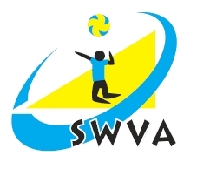
Ron Richards

3 Woodside Grove

Henbury
Bristol
BS10 7RF

mob: 0797 685 0618
Email: rricha7122@aol.com

April 10th, 2015

Dear Executive Officer / Area Secretary

I would like to provide you with notice of the SW Volleyball Association Annual General Meeting. This will take place on Saturday June 5th, 2021 at 10.30am and will be carried out online.

A link to the GoToMeeting will be provided with the agenda and papers.

I hope that you will be able to attend and help us to plan the future of volleyball in the SW (as best we can in the current circumstances).

I will distribute the agenda and Annual Report as soon as possible after May 30th. Could I please therefore ask you to send OFFICERS / AREA REPORTS TO ME BY May 25th by email - rricha7122@aol.com. I realise that there may have been little activity this year, but it would be helpful for the Association to have a historic record and I would ask you to report on plans for restarting volleyball in your area / area of responsibility.

Could you please let me know if you would be willing to stand or if you know of other suitable candidates willing to stand for office. It is particularly important to receive nominations in writing in advance to avoid having to receive proposals in the online meeting.

I have also attached a nomination form for the 2021 SWVA Annual Awards. Please nominate suitable people and please promote among your clubs / players. The form can also be accessed on the SWVA website: http://www.swva.org.uk/annual-awards-form

Yours sincerely

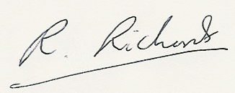

Ron Richards
Secretary SWVA.

SOUTH WEST VOLLEYBALL ASSOCIATION

2021 AGM – SATURDAY June 5th, 10.30am

Name (Block Capitals)............................................................ Club.....................................................................

Address..................................................................................................................................................................

Email .............................................................Tel No....................................................

Please circle / tick as necessary: I will / will not be attending the AGM

I would like to nominate the following for office at the AGM:

Position Present holder My nomination

Chairman Dave Reece .................

Vice Chairman Roy Pankhurst .................

Secretary Ron Richards . ................

Treasurer Neil Bentley .................

Competitions Secretaries Rachel Swindell .................

Officials Sec Chris Semmens .................

Coaching Sec vacant .................

Jun Dev Officer Jurek Jankowski (standing down) ................

Beach Volleyball Dev Officer Flo Ermeje .................

Sitting Volleyball Dev Officer Andrew Potter .................

Child Protection Officer vacant .................

Executive Officers:

Ben Fairweather ………. Charlie Huitson …………

Cliff Ball ............... Richard Parkes ………….

Signed ................................................................ Date ..................

Please return to Ron Richards (rricha7122@aol.com) by May 25th

